## Title of Your Article

John P. Smith and Jane Doe

Affiliation

Email: [info@email.com](mailto:info@email.com), Web Site: [www.myweb.com](http://www.myweb.com/)

**Abstract**

Please provide an abstract for the article (mandatory for SES research articles only, optional otherwise); this is a real timesaver for producing the annual newsletter and will ensure that your paper is faithfully summarized. The abstract should be a single paragraph and contain no references to numbered items in the remaining of the article.

### Introduction

The article should be prepared in Microsoft Word format using this document as a template. The maximum length of the article should not be more than 20 pages, including tables, figures, graphs, illustrations, appendices and references. Please follow the guidelines provided in this template.

#### How to Use this Template

Please do not start your article from last year’s template. Save the template **locally** on your computer, with a .dotx extension. Double clicking it will open a Microsoft Word document, which you can then save as a normal .docx document that will contain the required styles for formatting your article.

### Body of Article

#### Common Styles Used in This Template

Body texts are fully justified, without indent, as shown here. Please format your text only with the styles provided in this template and avoid as much as possible creating your own styles or formatting using the Font group (bold, italic, font size, etc.), unless no other option exists.

Table 1: Styles used and formatting examples.

|  |  |  |
| --- | --- | --- |
| **Style Used** | **Purpose in Article** | **Appearance** |
| Main Title | Title of your article | Title of Your Article |
| Section | Body Section Title | Introduction |
| SubSection SubSubSection Etc. | Body Subsection Title | Tables & FiguresIncluding Graphics and Images |
| Author | Name of Author | John P. Smith |
| Abstract | Text of the abstract | The abstract summarizes the article. |
| Affiliations | Affiliations, addresses and emails | Safe Engineering Services & technologies ltd.  Email: [info@email.com](mailto:info@email.com), Web Site: [www.sestech.com](http://www.sestech.com/) |
| Body Text | Normal Text  Key sequences | Body texts are justified at both ends.  Press Ctrl+A to select all. |
| Table Caption  Figure Caption  Figure Caption (long) | Table & Figure captions | Table 1: First table in this article  Figure 1: First figure in this article.  Figure 1: My informative figure, with a descriptive explanation text that spans more than one line is also centered. |
| Emphasis | Italic for referring to named items | using the Caption style for single line captions. |
| Strong | Bold for highlighting a comment  Also for Interface elements | All images should be **embedded** into your document.  Click on **OK**, then on **File | Save**. |
| Code | Code  F05 File commands | SOIL-TYPE,MULTILAYER,,,0 HORIZONTAL LAYER,TOP,244.454,6.67858,1.,1. LAYER,BOTTOM,756.159,,1.,1. |

#### Titles

Please use **Title Case** on the Main Title, Sections, Subsections, etc., i.e. all words should be capitalized, except for short articles, prepositions and coordinating conjunctions.

#### Tables & Figures

Place your figures and tables in the center of the page.

Number tables consecutively and use table numbers when referring to a table (Table 1, Table 2). Place the table headers above the tables, using the Table Caption style.

Number figures consecutively and use the figure number when referring to a figure (Figure 1). Place figure captions below the figures, using the Figure Caption.

Figure 1: Surface plot.

Figure 2: My informative figure, with a descriptive explanation text that spans more than one line is also centered.

##### Including Graphics and Images

The type of graphics you include will affect the quality and size of your article on the electronic conference proceedings media. In general, the use of vector graphics such as those produced by most presentation and drawing packages (i.e. Visio, PowerPoint, Freehand) can be used with minimal concern if each figure is grouped as a single object.

Bitmap images such as those produced when a photograph is scanned require significant storage space and must be used with care. Bitmap graphics store an image as a series of numbers that represent the color of each dot in the image. Increasing the dimensions, resolution (dots per inch) or number of colors in an image will dramatically increase the storage size of the image. If your article contains many large images, they will be down sampled to reduce their size during the conversion process. However, the automated process used will not always produce the best image, and you are encouraged to perform this yourself on an image-by-image basis.

Suggestions for improving the quality of bitmap graphics include the following:

* In general, bitmapped images should be limited to no more than 256 (8-bit) color/grayscale, and 300 dpi.
* Select high resolutions for images that a reader will magnify. Image resolutions do not increase when readers zoom in on an image.

All images should be **embedded** into your document. Also please avoid overlays of images/graphics, for example by circling something in an image with one of Word’s shape tool, as the shape and the image may have their relative positions accidentally shifted during final formatting. In this case it is better to take a screenshot of the overlaid images/graphics and replace them by the screenshot. Window’s Snipping Tool can help for creating screenshots.

Do test that each image resizes properly and that the surrounding text adjusts itself naturally. To achieve this, it is recommended to use the option **Wrap Text | In Line with Text**, from the image’s right-click menu.

#### Equations

Number equations consecutively with equation numbers in parentheses flush with right margin, as in equation (1):

|  |  |  |
| --- | --- | --- |
|  | $f\left(x\right)=a_{0}+\sum_{n=1}^{∞}{\left(a_{n}\cos{\frac{nπx}{L}}+b_{n}\sin{\frac{nπx}{L}}\right)}$. |  |

In order to automate the numbering of equations in this format (for Word 2007 and above), select the entire table below containing an equation placeholder, then select **Save Selection to Equation Gallery** from the **Equation** menu under **Equation Tools | Design**, as shown in Figure 3.

|  |  |  |
| --- | --- | --- |
|  | |  |

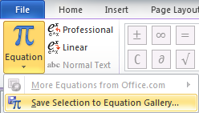

Figure 3: Saving Numbered Equation template to the Equation Gallery.

Figure 4 shows appropriate settings for the new equation preset.

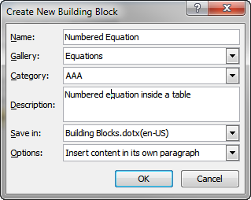

Figure 4: Settings for saving the Numbered Equation template to the Equation Gallery.

You can now insert the numbered equation format using **Insert | Equation | Numbered Equation**, as shown in Figure 5.

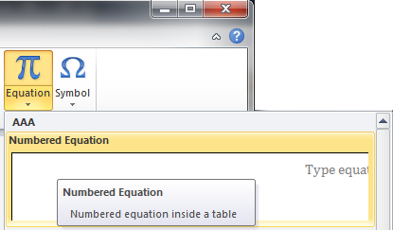

Figure 5: Inserting the Numbered Equation template from the Equation menu.

Once an equation has been typed and numbered using the procedure above, it can be cross-referenced, provided a Bookmark is first created to its reference number. In order to do that, click on the equation number to select it and click on **Insert | Bookmark**. Give the bookmark a name that starts with a letter and that does not include any spaces. Figure 6 gives an example for the equation above.

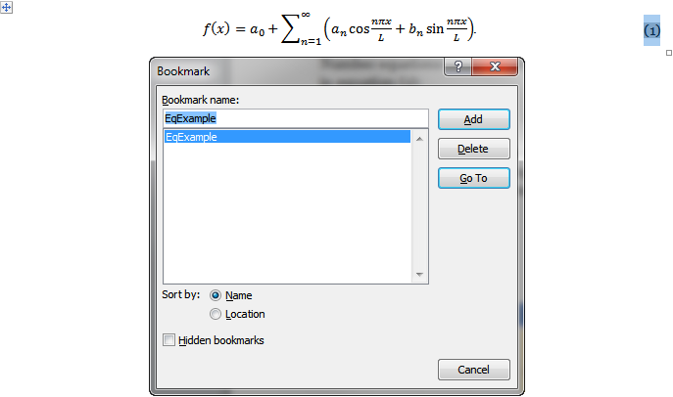

Figure 6: Creating a bookmark for an equation number.

Now, cross-references to Equation (1) can easily be inserted in the text by using the **References | Cross-reference** tool, with a reference to the **Paragraph number (full context)**, as shown in Figure 7.

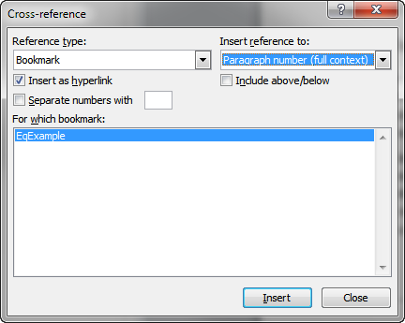

Figure 7: Inserting a cross-reference to an equation number.

In order to refresh all the fields in the document and thus update the equation and cross-reference numbering, select the whole document with Ctrl+A, then press the F9 key on the keyboard.

Please, explicitly restart the equation numbering at 1 for the first equation of your article (Right-click on the first equation number, then **Set Numbering Value** to a new list starting at 1).

Lastly, note that equations are part of the text and should therefore be followed by the usual punctuation, as required by the context.

#### Units

It is recommended to use a space before writing the units of a physical quantity and not to use any special formatting for them (no italic), e.g. 115 kV or 100 Ω m.

To generate a non-breaking space that will keep the numerical value and unit symbols together on the same line, you can use the keyboard shortcut Ctrl+Shift+Spacebar. Turning on the display of hidden formatting symbols () will confirm the insertion of a non-breaking space by displaying it as a degree symbol ().

#### Example Files

Articles can be supplemented with example files that will be shared with the conference attendees. References to their location should be made to the “UGC 2020\Example Files\<Article Folder> subfolder of the SES Software conference distribution”, where <*Article Folder>* is normally named the same way as your article, provided the name is short enough. You can confirm the name of that folder by emailing at [ugm@sestech.com](mailto:ugm@sestech.com?subject=UGM:%20Example%20Files%20folder).

### Conclusion

Briefly recall the context and important results of the article so that an eventual reader can grasp the major points by reading the conclusion alone.

### Acknowledg(e)ment (Optional)

Author X thanks colleague Y for careful reading of the manuscript and useful suggestions.

### References

Include any references in a separate section at the end of the document, formatted as shown in reference [1]. If using Word’s Citation & Bibliography tools, this is style IEEE 2006.

|  |  |
| --- | --- |
| [1] | J. P. Smith, "Reference Doc. Title," in *CDEGS Users' Conference Proceedings*, Rock Creek Resort, Montana, USA, 2012. |

### Important Dates

Table 2: Important dates.

|  |  |
| --- | --- |
| April 24, 2020 | Submission deadlines for your article **title** |
| May 15, 2020 | **Draft** article submission due |
| May 29, 2020 | **Final** article due |
| June 23 – 26, 2020 | **Conference** dates |

### Article Submission

Please submit your paper as a Microsoft Word document (.docx). This will allow the editors to perform last minute fixes regarding the formatting or pagination for instance (inclusion of the article number) and will also make it easier to generate the table of contents. However, before submitting your paper, please ensure you can successfully save it as a PDF document as well (using Word’s **Save As** dialog), paying special attention to the good rendering of figures as sometimes objects using transparency become opaque during the conversion. This will minimize the risk of conversion problems during the last step of the conference proceedings creation. Your document should also be completely free from **Comments** and **Track Changes** notes, unless they are intended for the editors assembling the proceedings.

In order to efficiently distribute author’s submissions and thereby increase the visibility and overall impact of the work, copyright of all submitted work is transferred to SES. This will allow SES to share the work with people both within and outside the present Users’ Group membership. After the conference, authors are still free to share their submission with others.

For all future correspondence regarding the article submission, and any questions regarding the formatting of your article, please send an email to [ugm@sestech.com](mailto:ugm@sestech.com?subject=UGM:%20Article%20submission).